Scripting Task

Task Description:

- Create a shell script to print the HTTP error code of guvi.in & print, the success/failure message based on the error code response
- Given a file, replace all occurrence of the word "give" with "learning" from 5th line till the end in only those lines that contain the word "welcome"

Techstacks needs to be used :

- Shell (AWS, Gitbash)

Tasks

Task1
- Create a file with .sh extension using command

nano 01_http.sh

- Update the script code to SH file
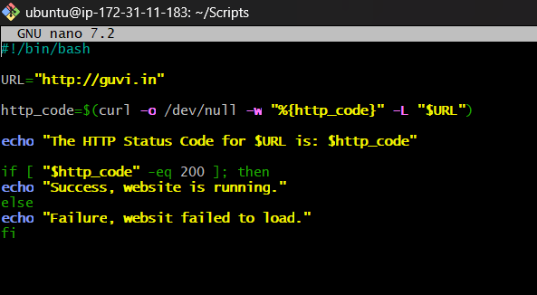

- Update the user with execute permission

Chmod +x 01_http.sh

- Execute the script using below command

./01_http.sh
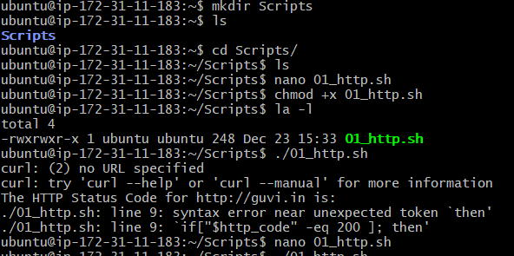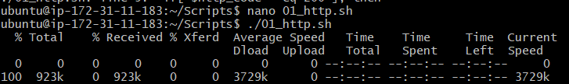

- If the website runs it should give message as website running
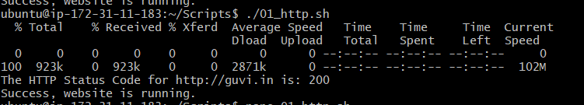
- If the website is not working it gives message as failure(below example when tried adding an extra “i” to “guvi” making it “http://guvii.com”
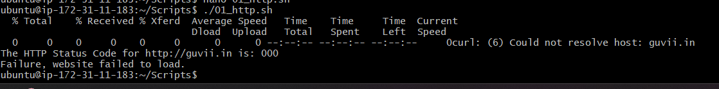

Task 2

- Create a text file using cat command with multiple line texts.
Cat > task.txt <<EOF
- Welcome give
- give
- welcome
- Give
- Welcome give
- Give only
- Welcome give give
EOF

- Use below command to replace as requested

Sed ‘5,$ { /welcome/ s/give/learning/g}’ task.txt

- Observe in output the words has replaced word "give" with "learning" from 5th line till the end in only those lines that contain the word "welcome"

